ASSIGNMENT 24

Name : Akanksha Joshi

Roll No : B038

Batch : 3

Div : BTech CS B

-------------------------------------------------------------------------------------------------------------------------

Q.Consider a scenario from ABC Training Institute. The given table shows the marks scored by students of grade XI in Python Programming course.

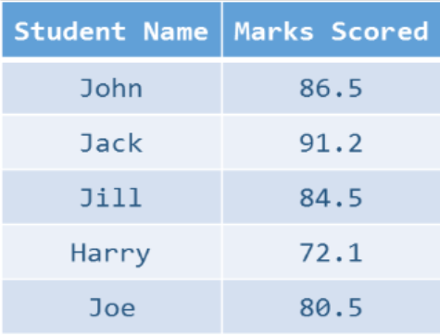

Write a Python program to meet the requirements mentioned below:

a. Display the name and marks for every student.

b. Display the top two scorers for the course.

c. Display class average of this course.

Hint- Implement the solution using a dictionary.

Source Code

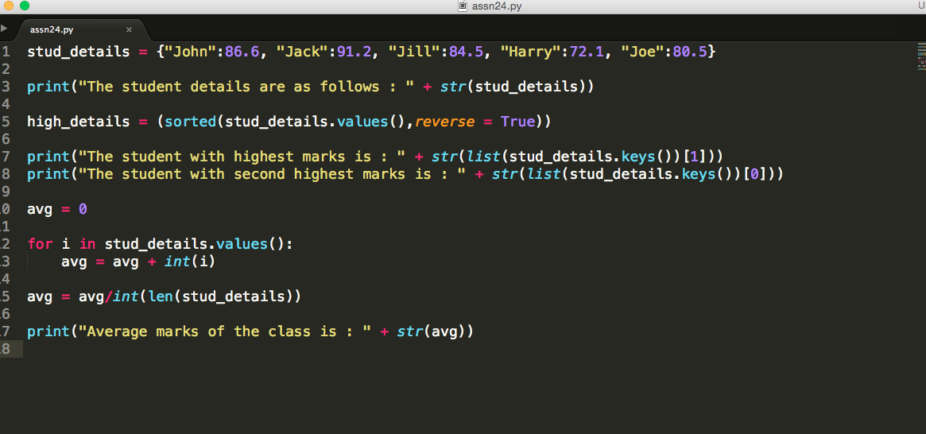

Output

The student details are as follows : {'John': 86.6, 'Jack': 91.2, 'Jill': 84.5, 'Harry': 72.1, 'Joe': 80.5}

The student with highest marks is : Jack

The student with second highest marks is : John

Average marks of the class is : 82.6